
AMERICAN INTERNATIONAL UNIVERSITY-BANGLADESH
Faculty of Science and Technology
Department of Computer Science
CSC 3215: Web Technologies

Semester: Summer 2025-26 | Group No: 02 |  | Section:AA

Group Members:
SL. | Student ID | Name | Role | Signature
1 | 24-58125-2 | Safayet Gazi Sopan | Group Leader
2 | 25-60626-1 | Shawly Ahmed | Member
3 | 23-53685-3 | Samiat Alam | Member
Project Title
Simple Market - A local marketplace management system
Short Description
We are building SimpleMarket, a small multi-seller marketplace web app for local shops in Dhaka. It connects customers, sellers, riders, and an admin on one platform, covering everything from browsing a product to having it delivered. Built with PHP and MySQL.
Introduction
Most small shops here still sell through Facebook pages or phone calls, with no proper way to track an order. SimpleMarket is a simpler alternative. A seller registers and gets approved by the admin, then lists products. A customer browses and orders, or offers a lower price and negotiates. Once the seller confirms, a rider claims the delivery and updates its status until it arrives. The admin approves sellers, sets commission rates, and views overall sales.
We built it as a three-member team using PHP, MySQL, HTML, CSS, and JavaScript, dividing the work by user role and managing it through GitHub.
Background Study
Daraz and Chaldal work well but are built for large sellers, and joining them as a tiny shop is not realistic. Facebook Marketplace is what most small sellers actually use, but it has no order tracking, stock management, or delivery structure — everything happens in comments, and orders get lost. Foodpanda handles the rider side well, showing a three-sided system can work, but it only covers restaurants.
We also noticed that bargaining is normal in local buying and selling, yet almost no platform supports it. That became one of our main features. So SimpleMarket keeps the useful parts — seller approval, order status, assigned riders, commission — while staying simple enough for a small shop to use.

ER Diagram
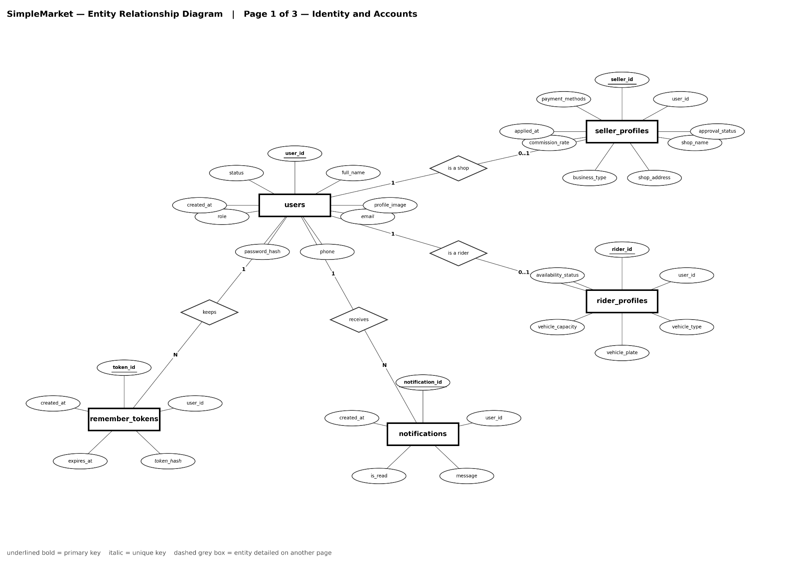
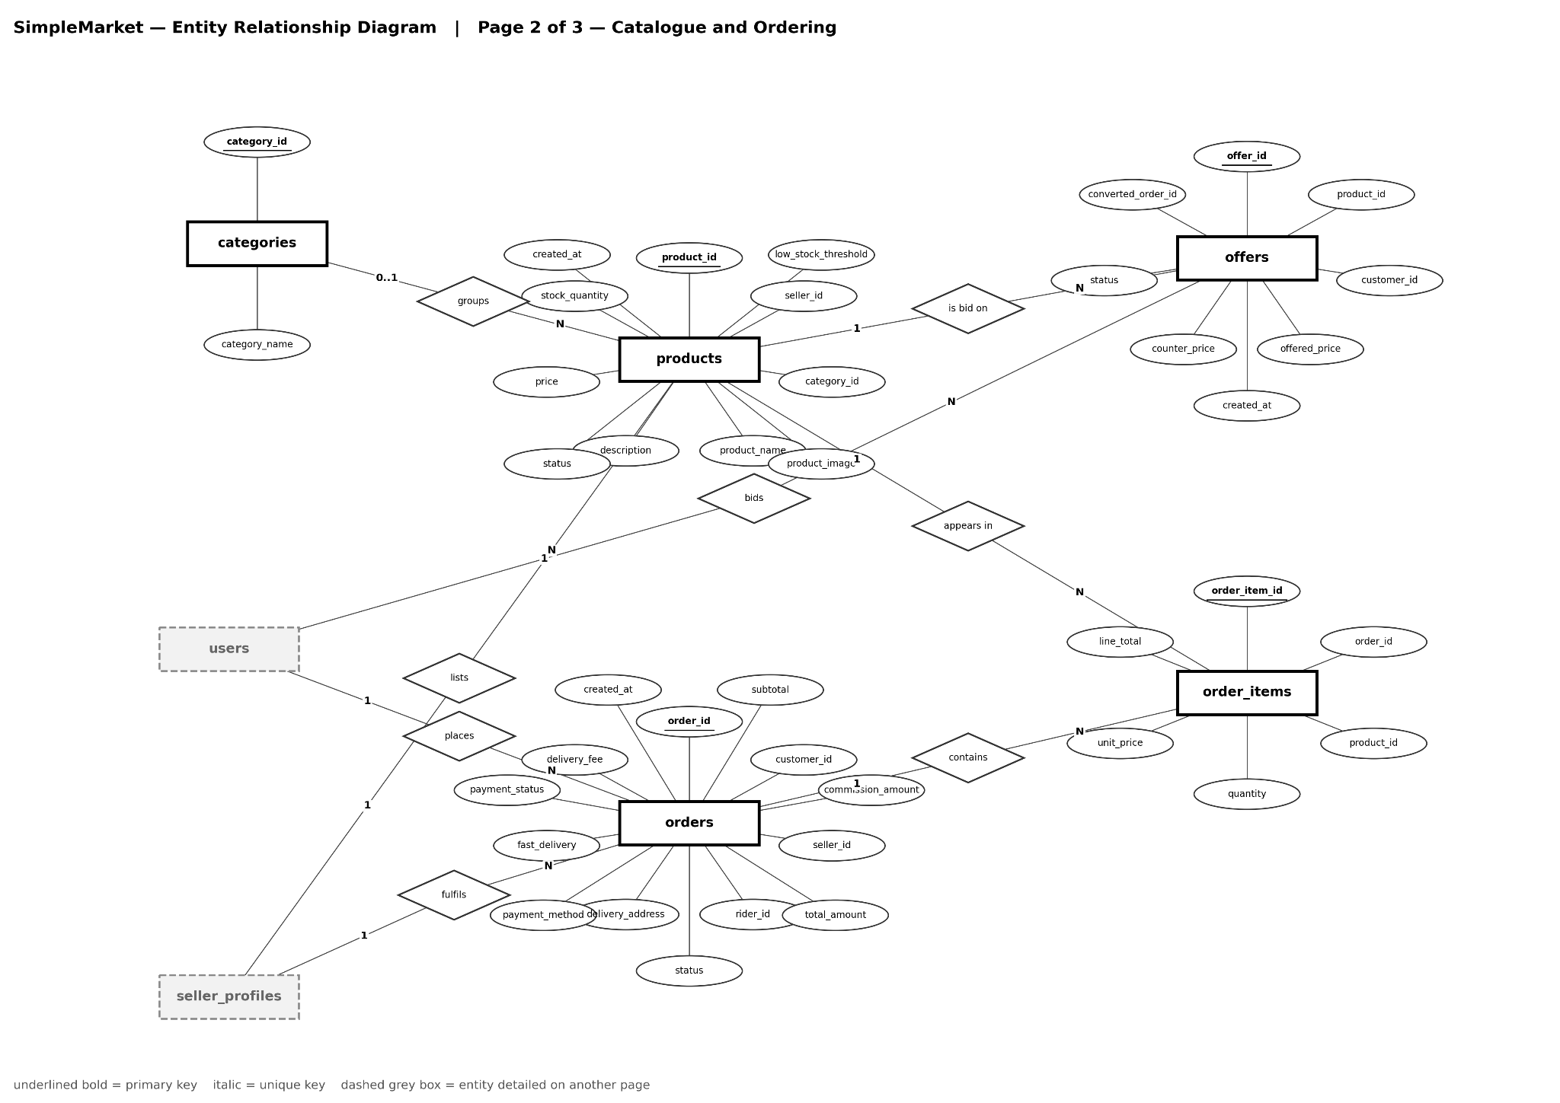

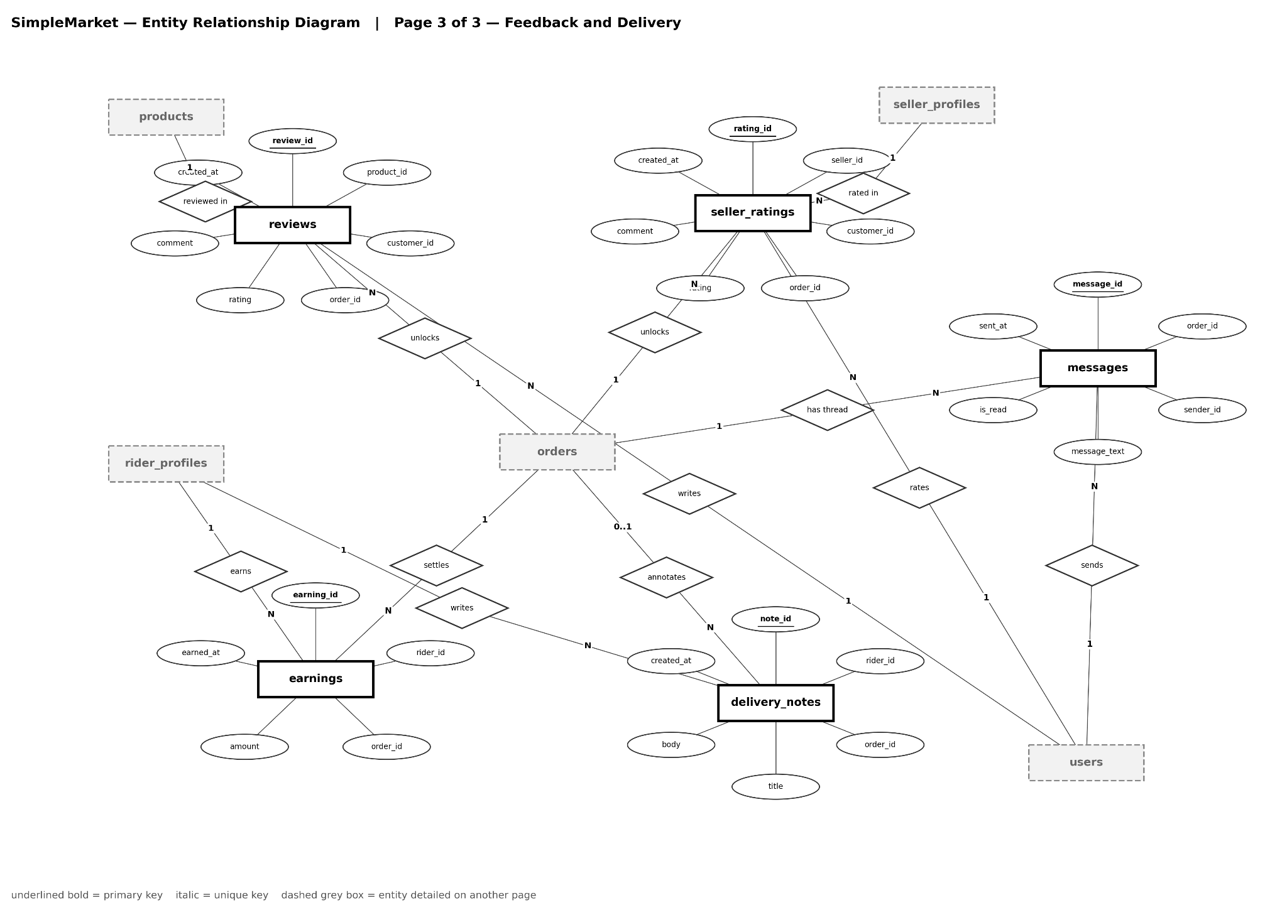
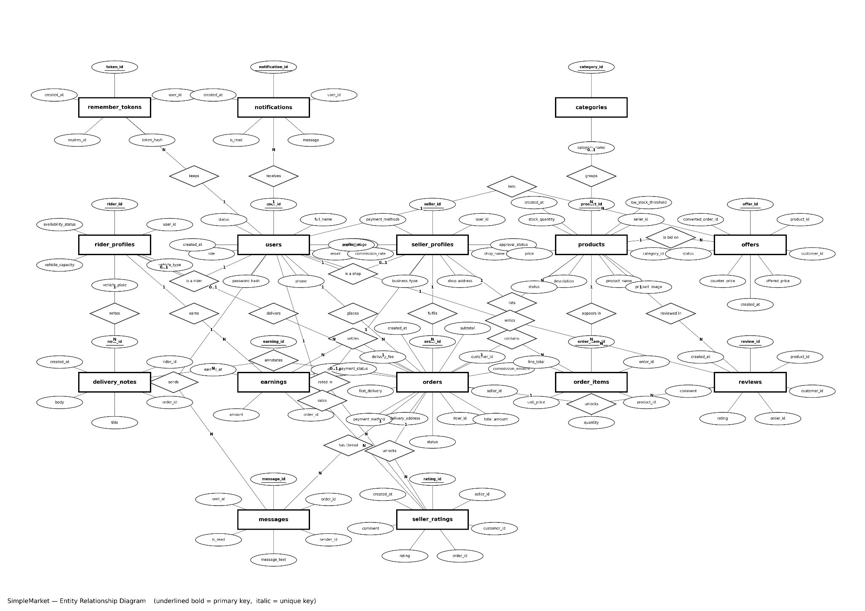
Use Case Diagram
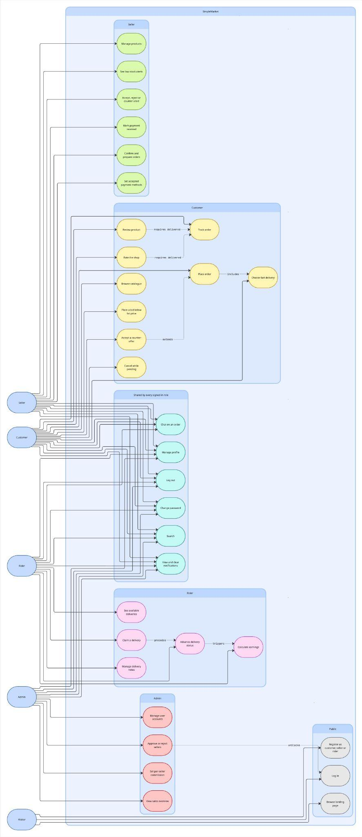
UI (Figma/Sketch)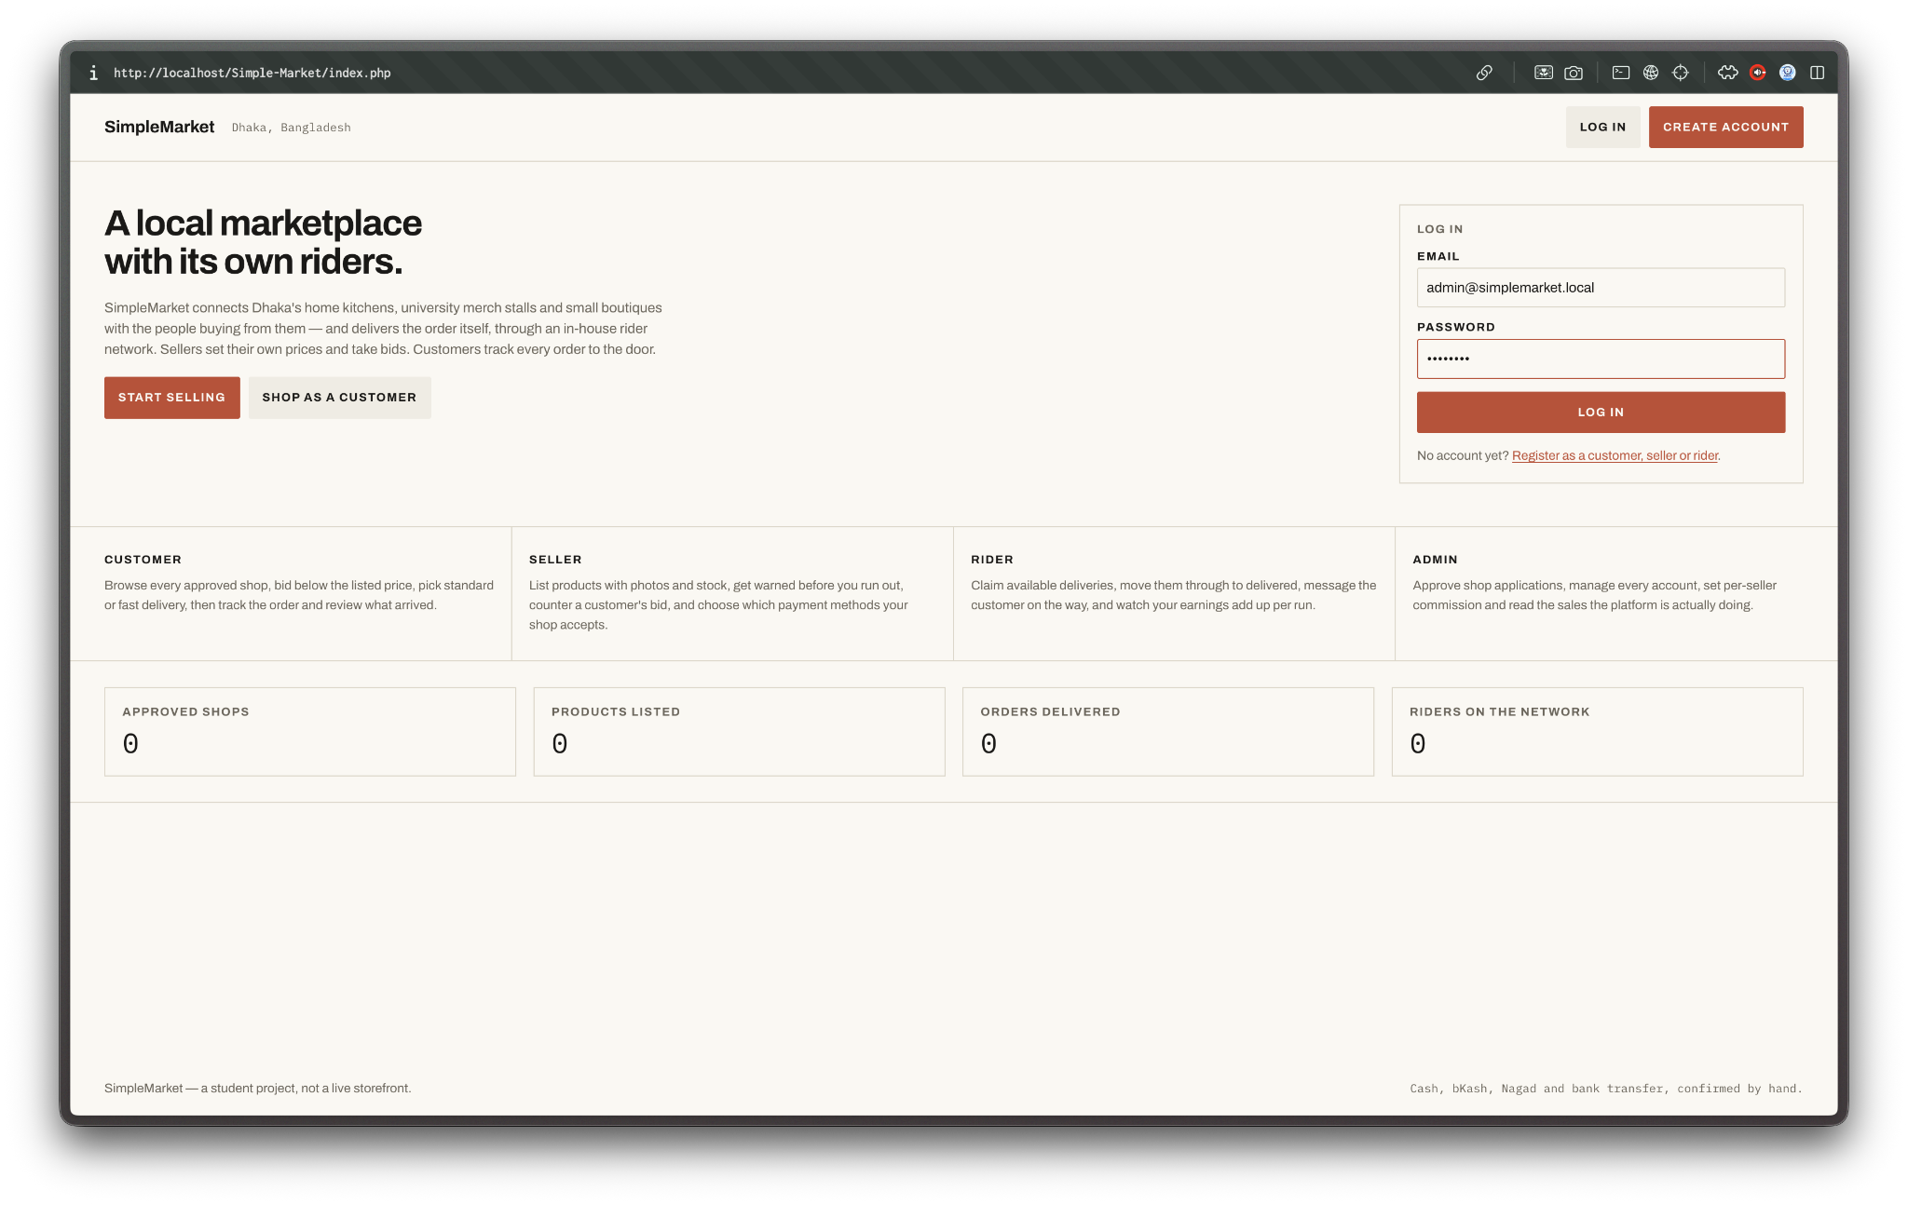
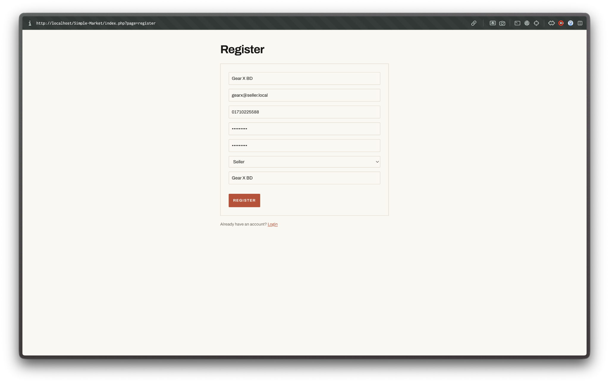
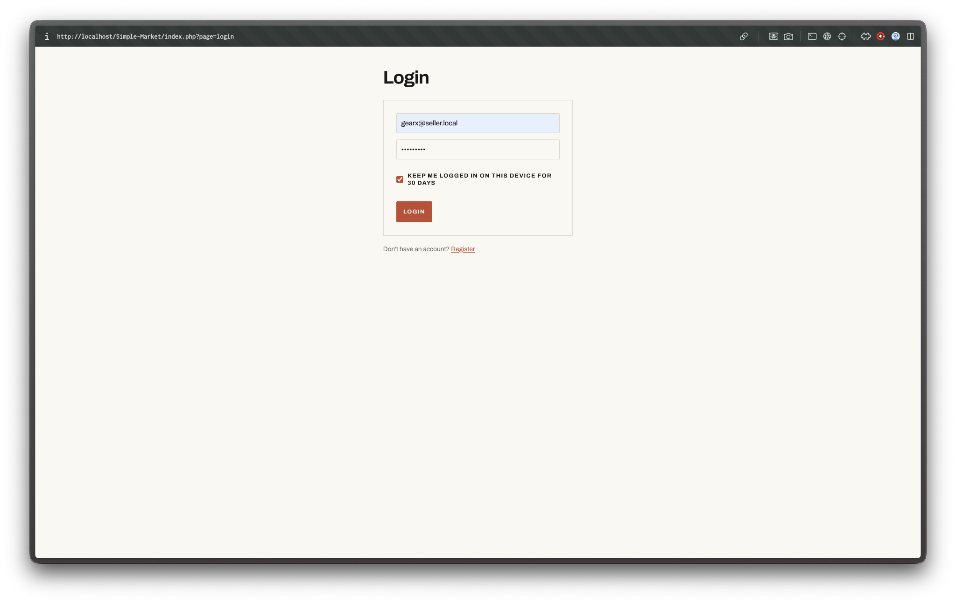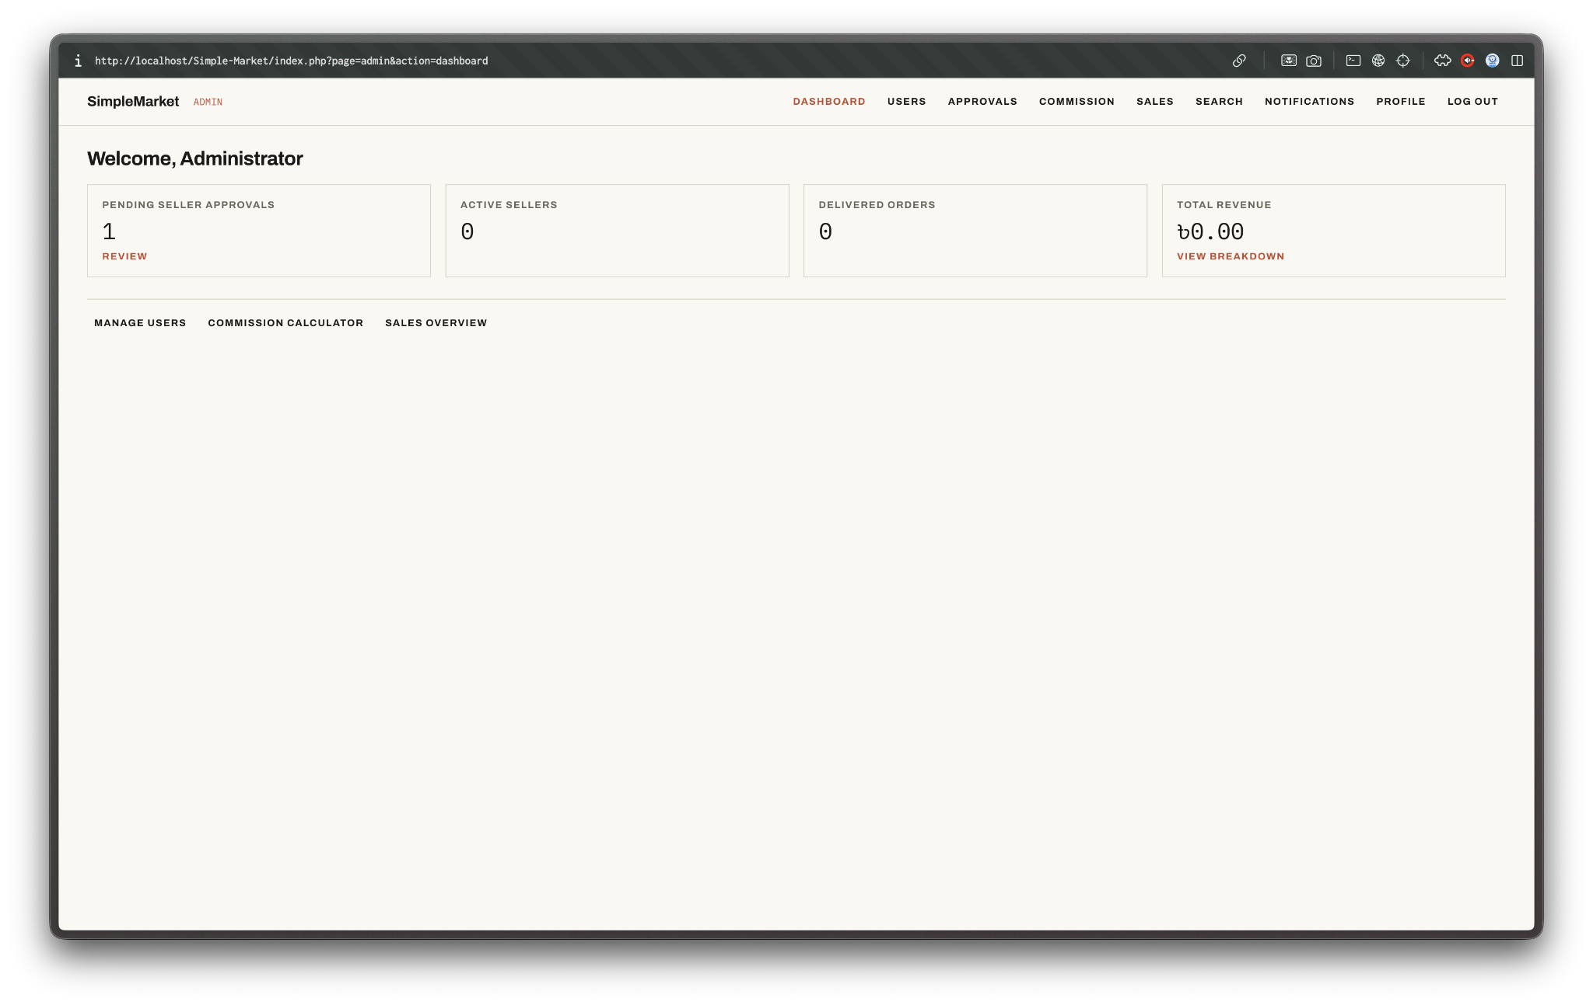
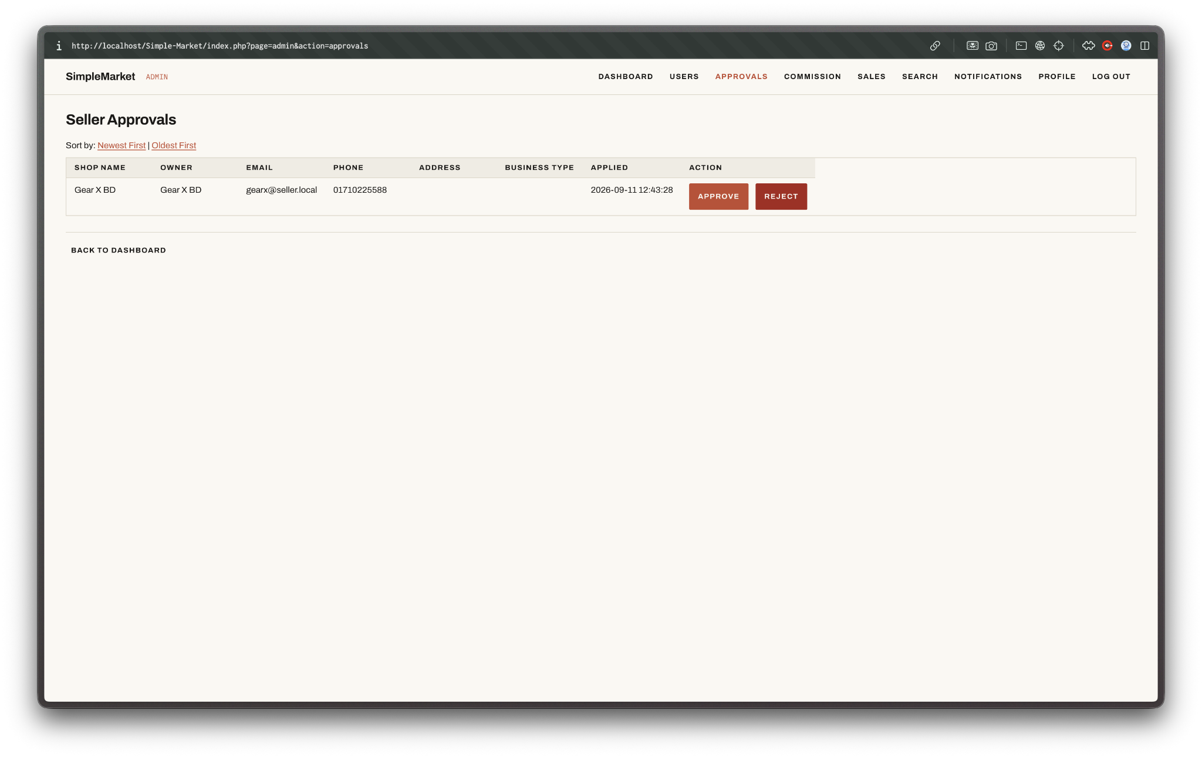
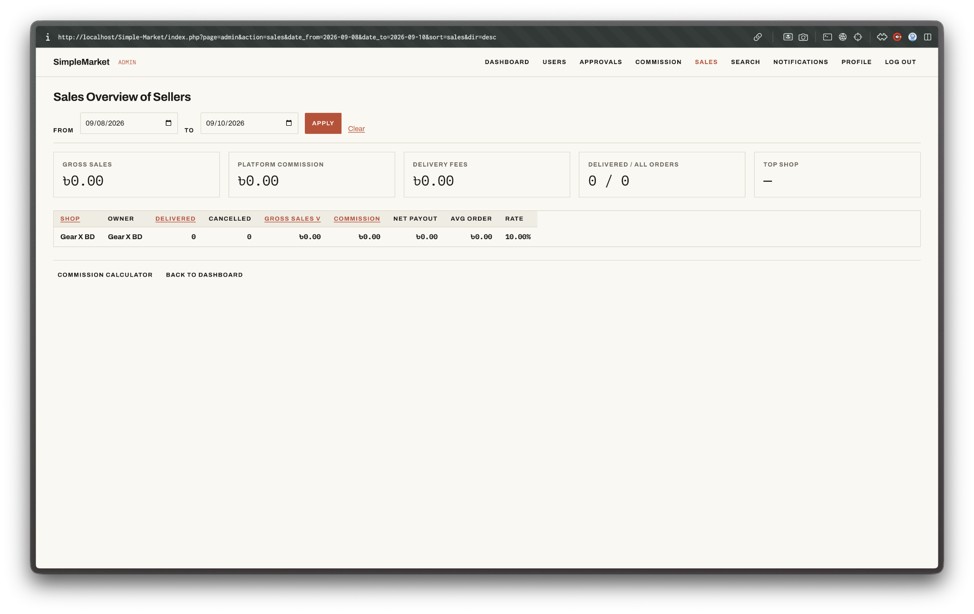
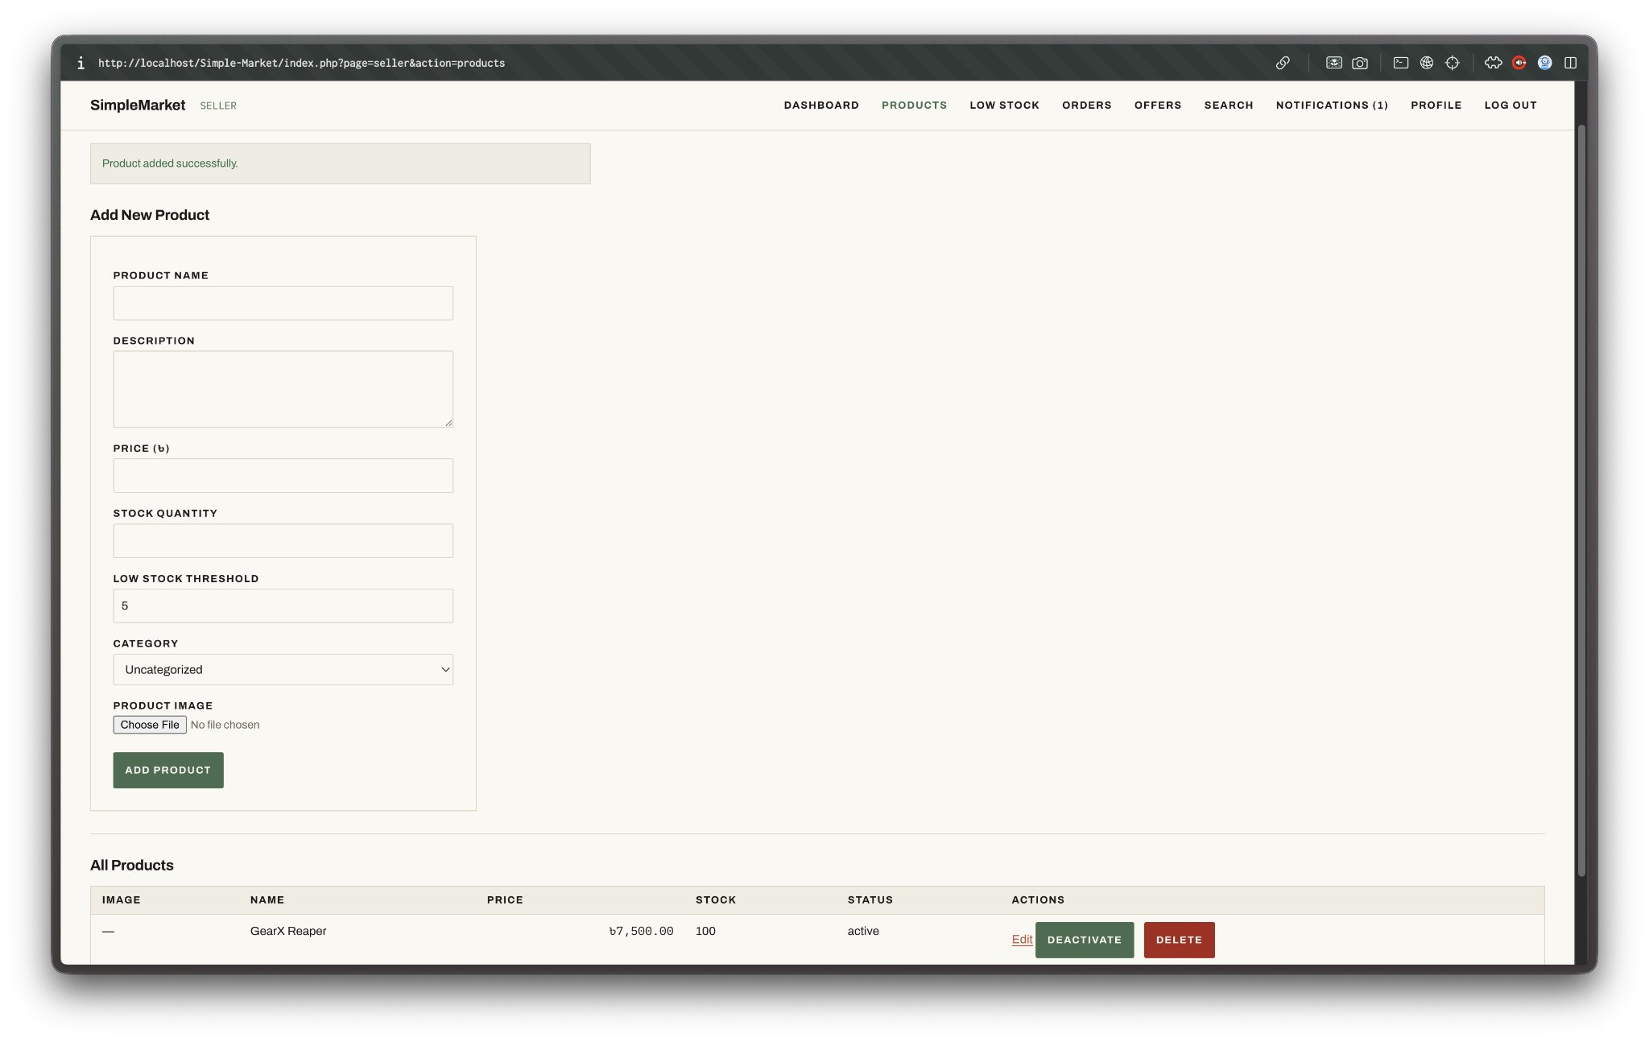
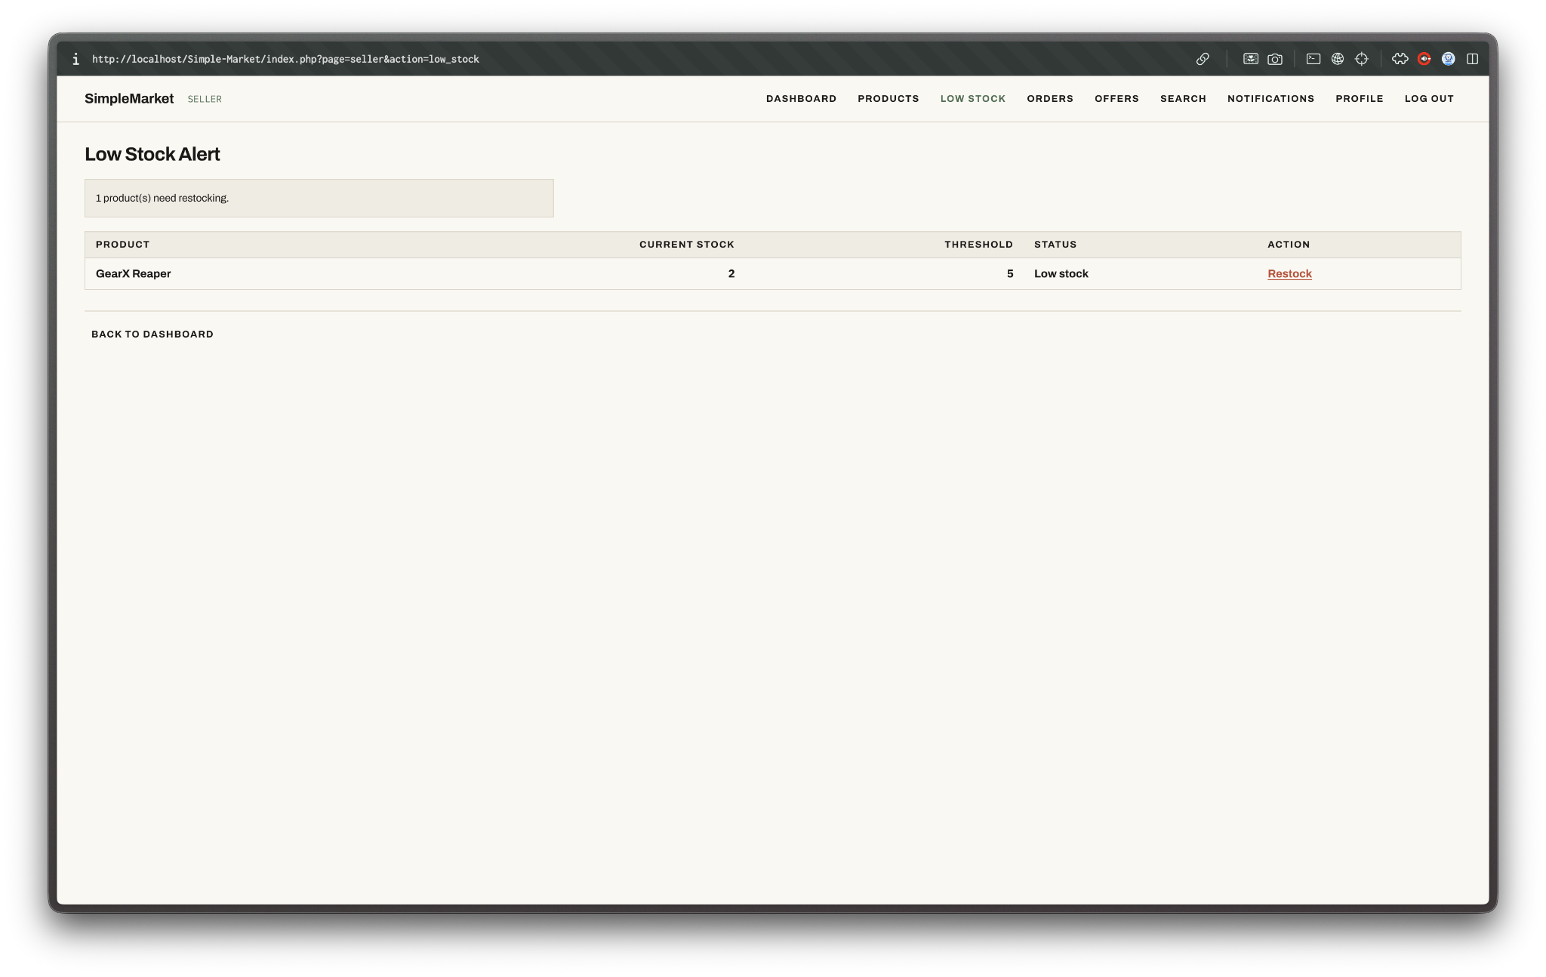
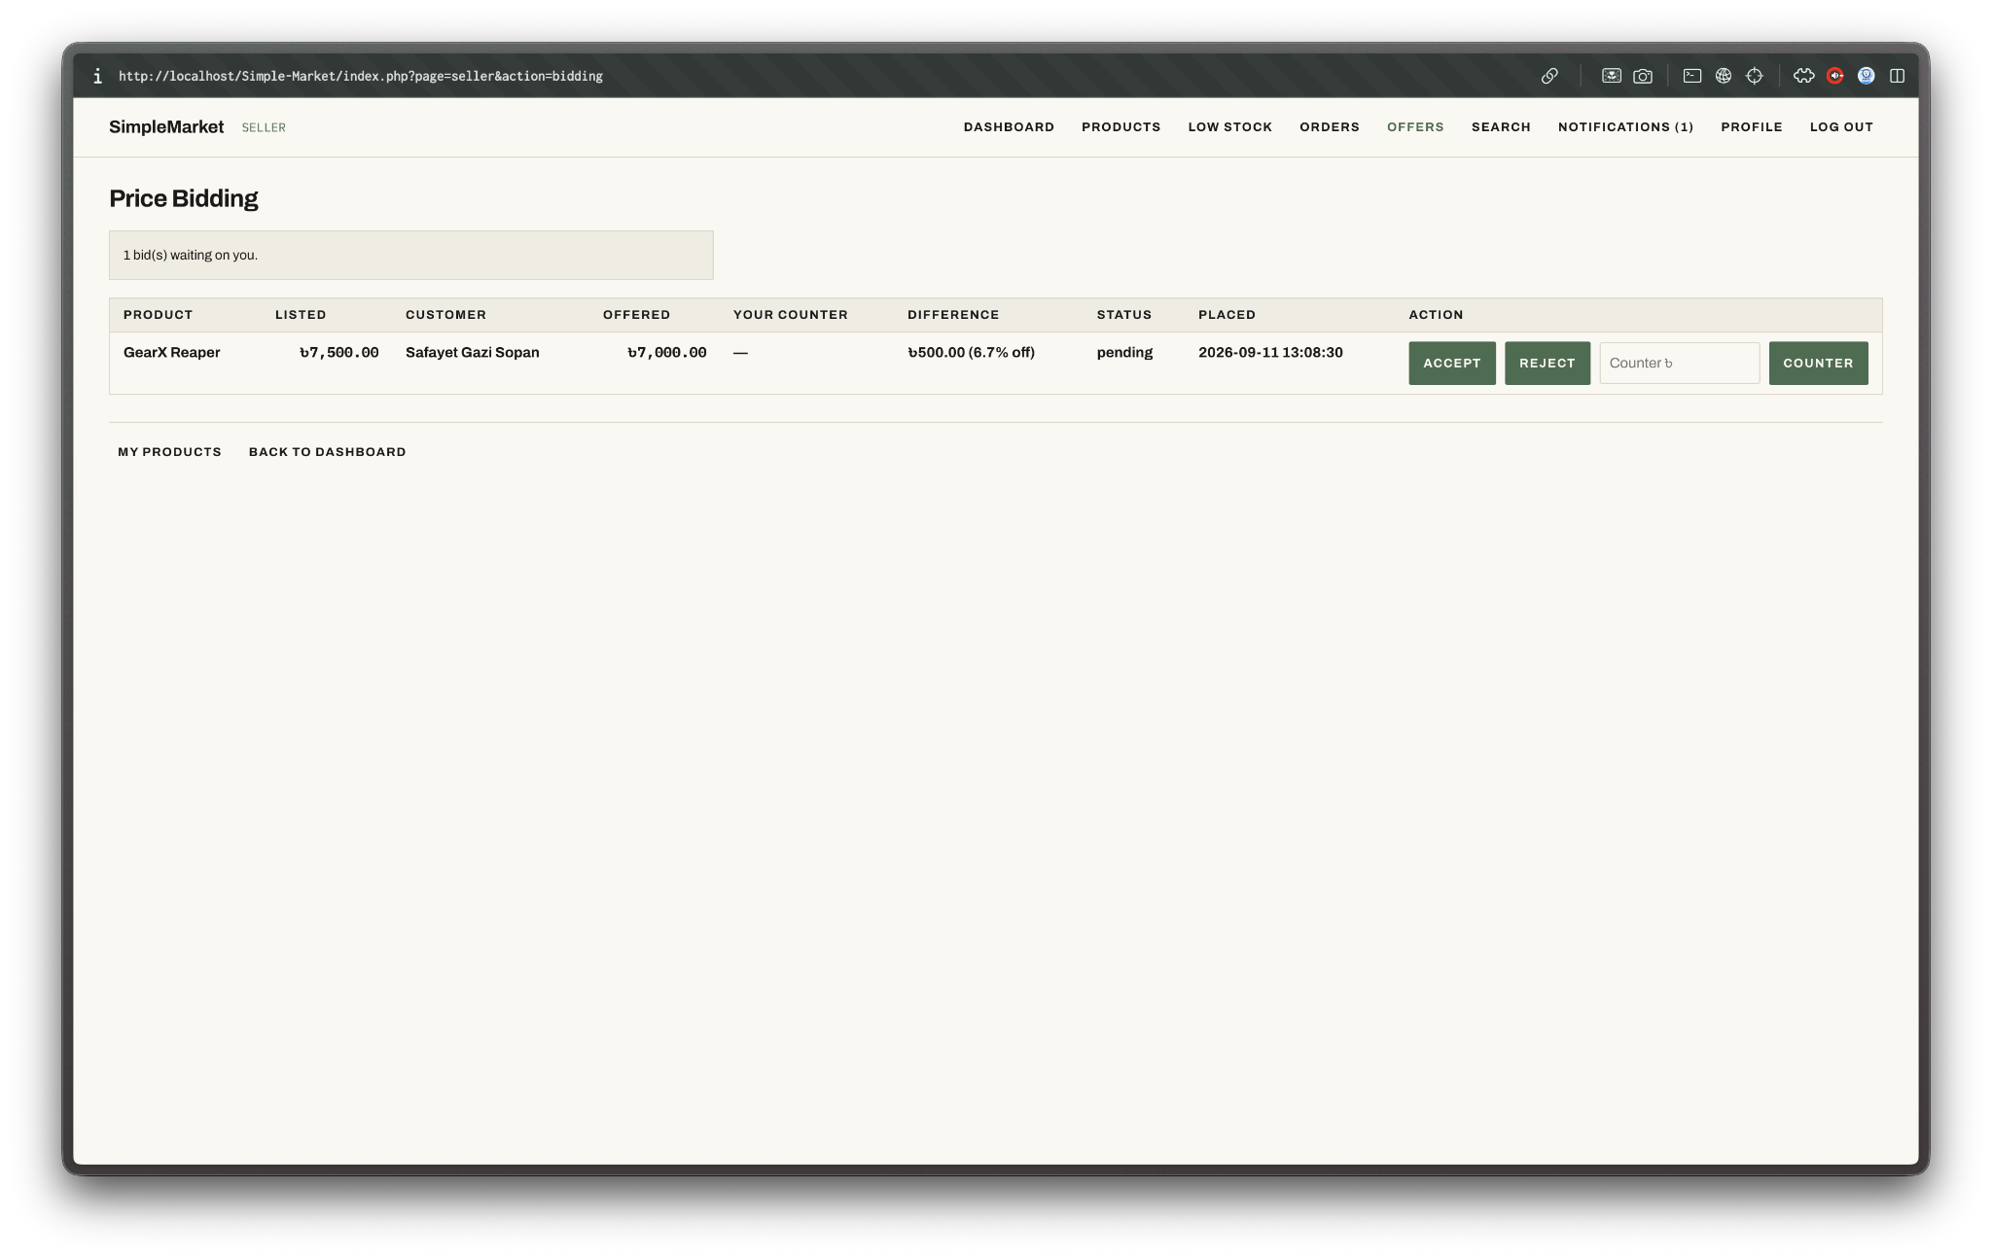
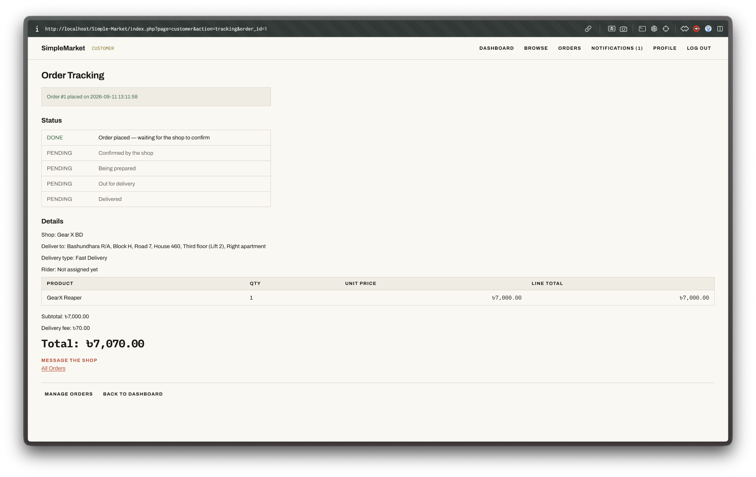
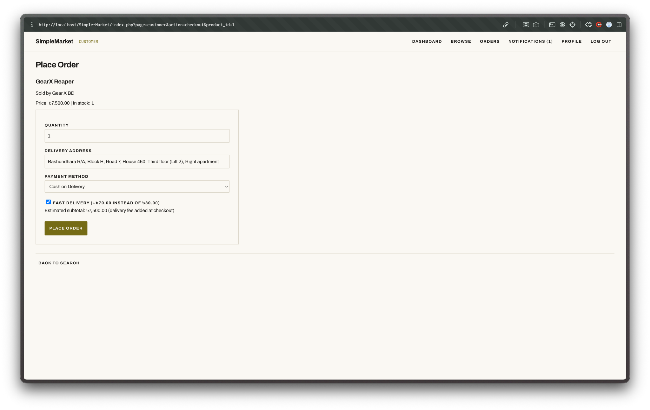
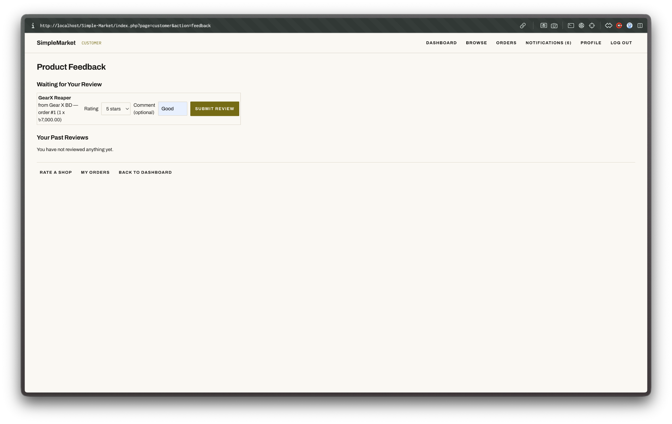
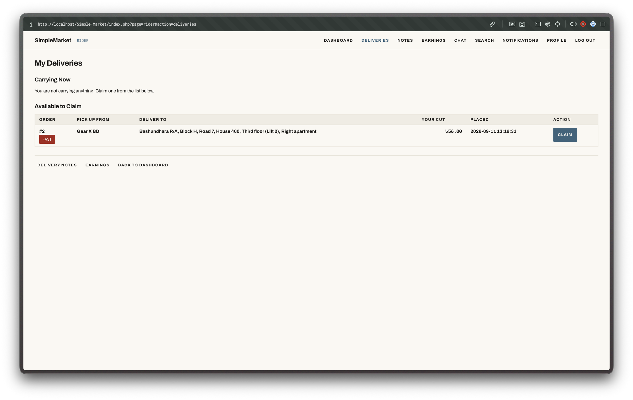
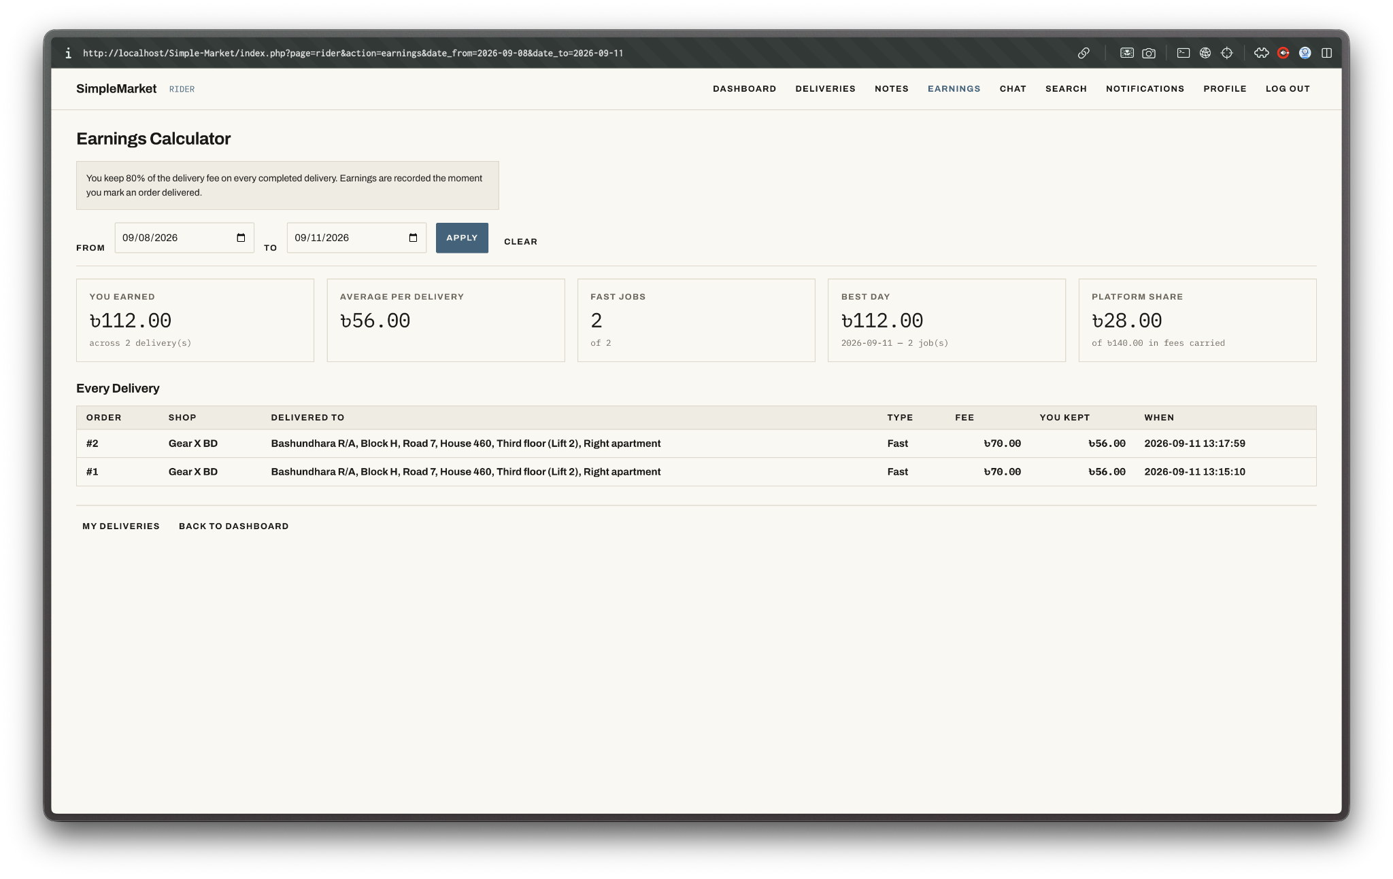
Types of Users: 1. Admin 2. Seller 3. Customer 4. Rider
Common Features (Available to All Users)
- Authentication
- Login to the system
- Logout from the system
- User registration
- Account Management
- Change or reset password
- Manage profile information (view, edit, delete)
- Dashboard
- Access a personalized dashboard after login
Specific Features by User Type
- Features of Admin
- Manage user accounts (create, edit, delete)
- Approve or reject seller applications
- Set per-seller commission rates and view the sales overview
- Features of Seller
- Manage products (add, edit, delete, set stock) with low-stock alerts
- Confirm and prepare orders, and mark payment as received
- Accept, reject, or counter a customer's price bid
- Features of Customer
- Browse the catalogue and place an order, with optional fast delivery
- Place a bid below list price and accept a seller's counter-offer
- Track the order, then review the product and rate the shop
- Features of Rider
- View available deliveries and claim one
- Advance the delivery status until delivered
- Manage delivery notes and calculate earnings

N.B: Each user type must have at least 3 distinct features different from the others. Additional features may be added if desired. Proposals with generic, incomplete, or duplicated features across user types will receive reduced marks under the criteria below.

